Dicks & Dames
The Noir RPG

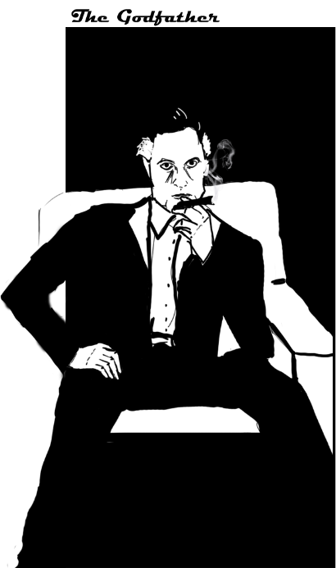
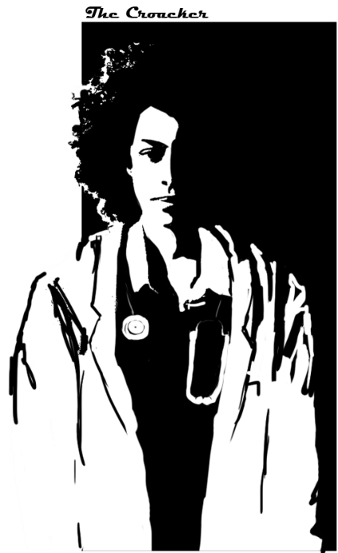
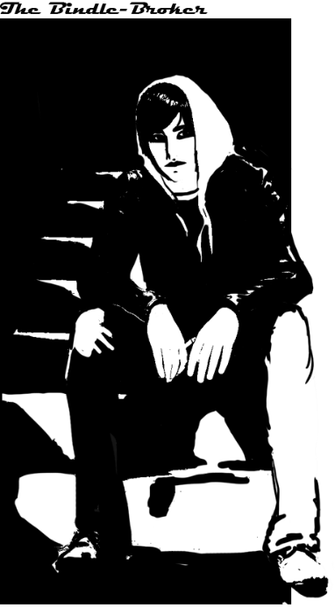

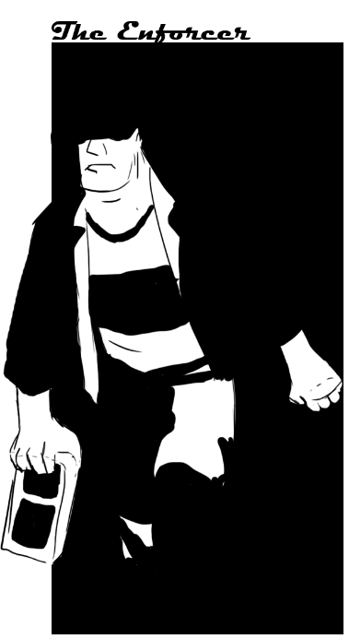
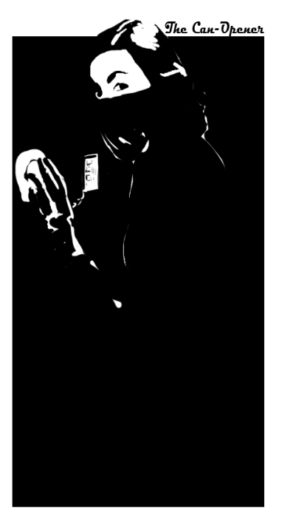
Pages 11 & 12
Pages 7 & 8
Pages 3 & 4

Pages 9 & 10
Pages 5 & 6

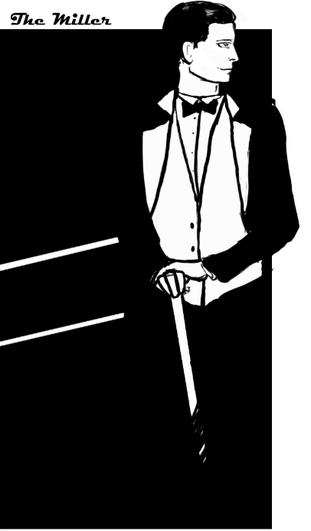
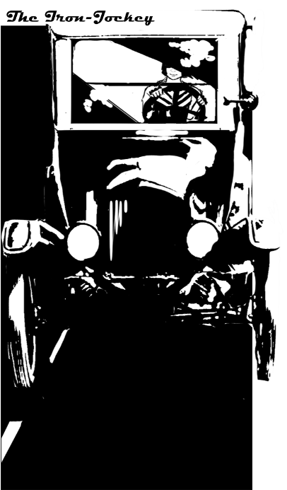
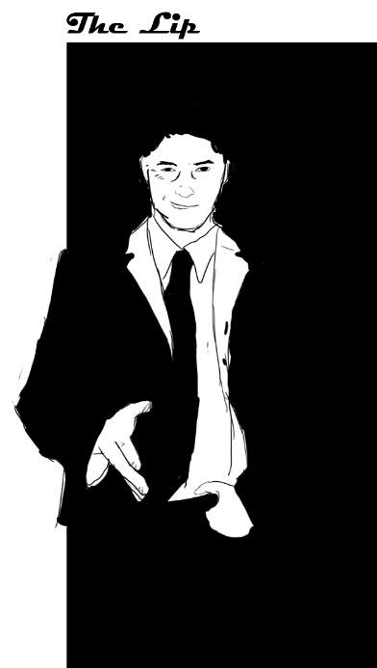
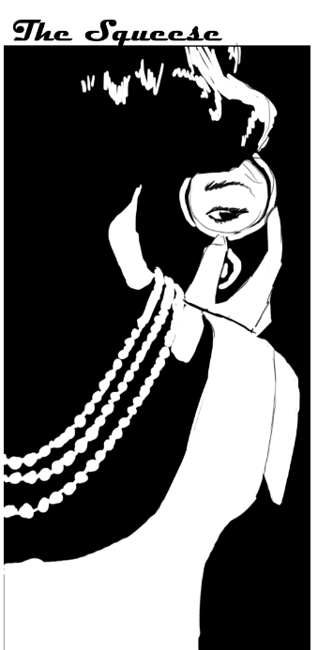
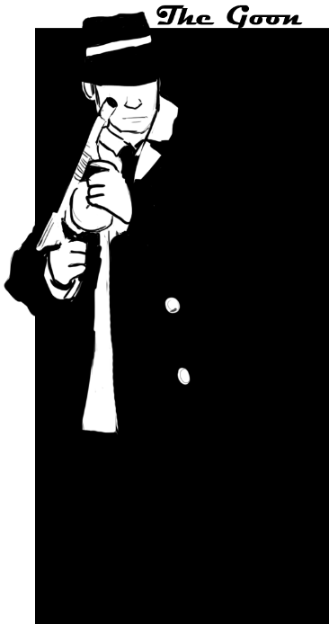

Pages 21 & 22
Pages 17 & 18
Pages 13 & 14


Pages 15 & 16
Pages 19 & 20
Basic Rules, Battle Rules & Harm – Pages 23-27
Optional Slang Sheets – Page 28
MC Rules, Tips & Threat Map – Pages 29-31
Credits – Page 32

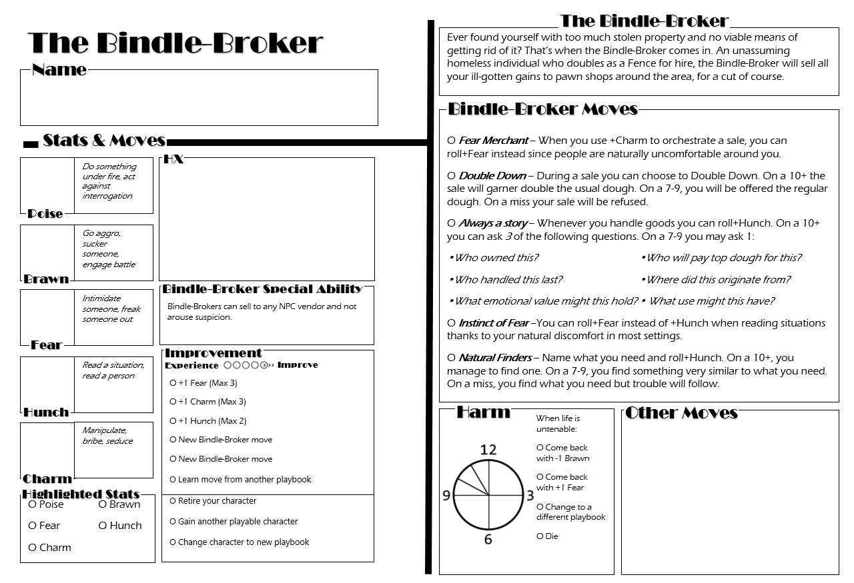
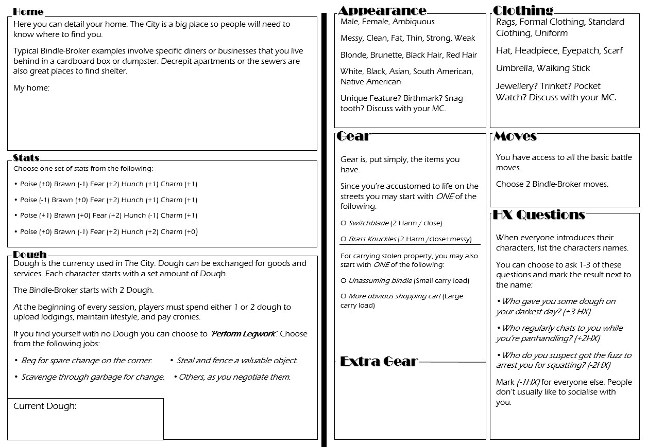
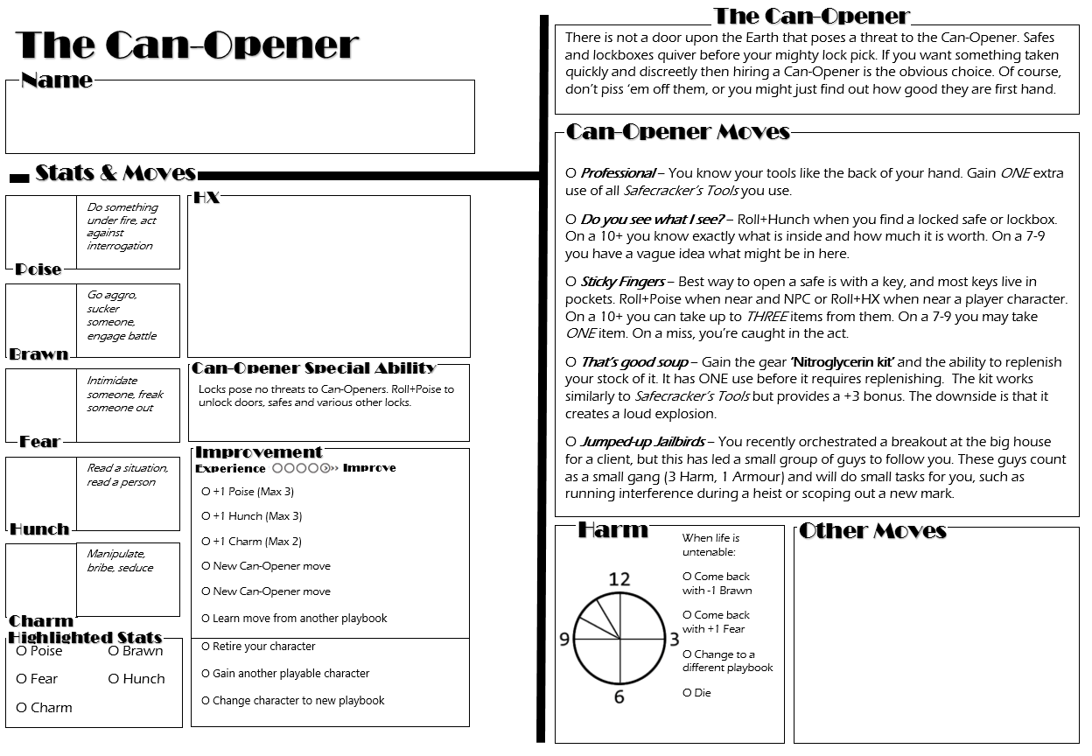
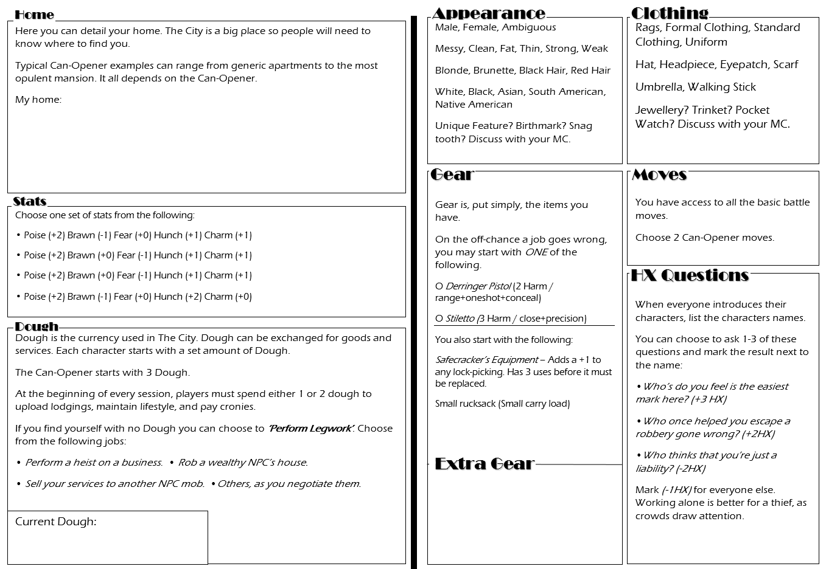
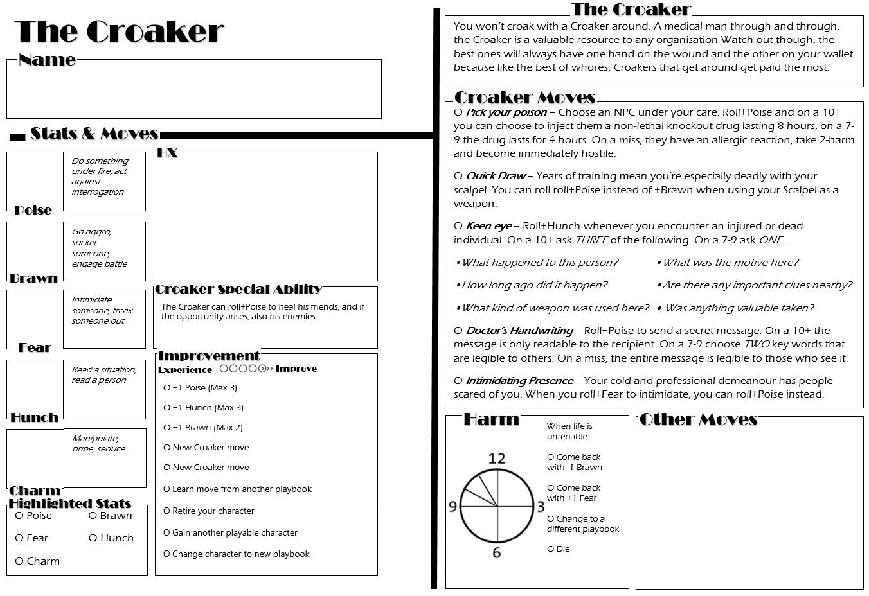
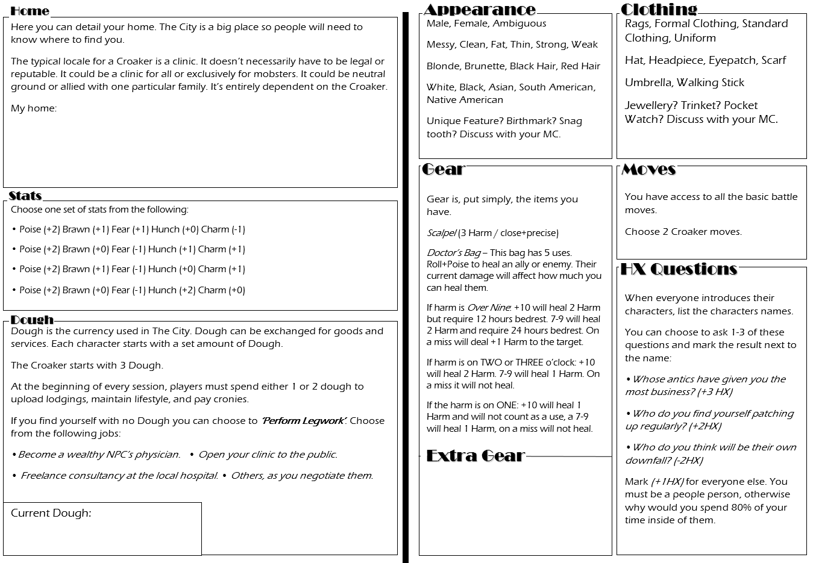

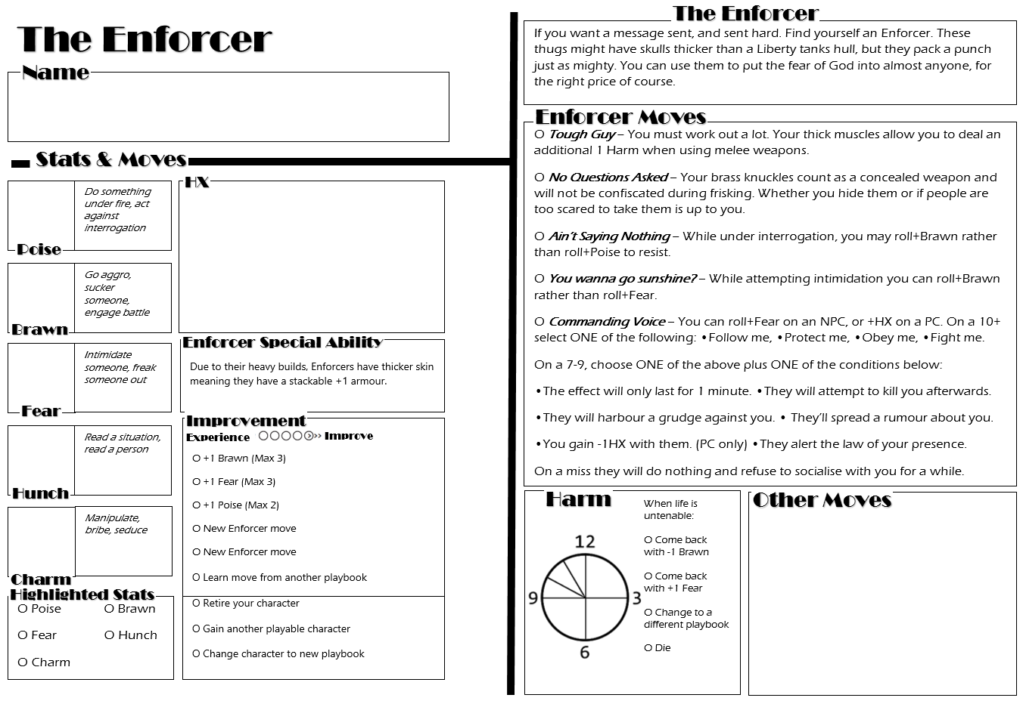
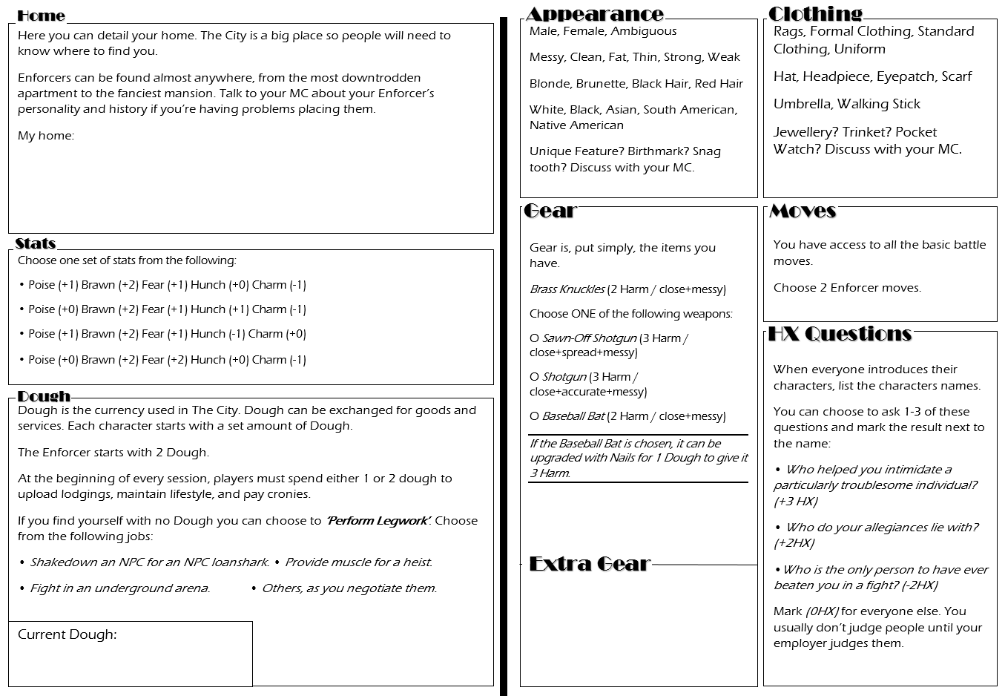
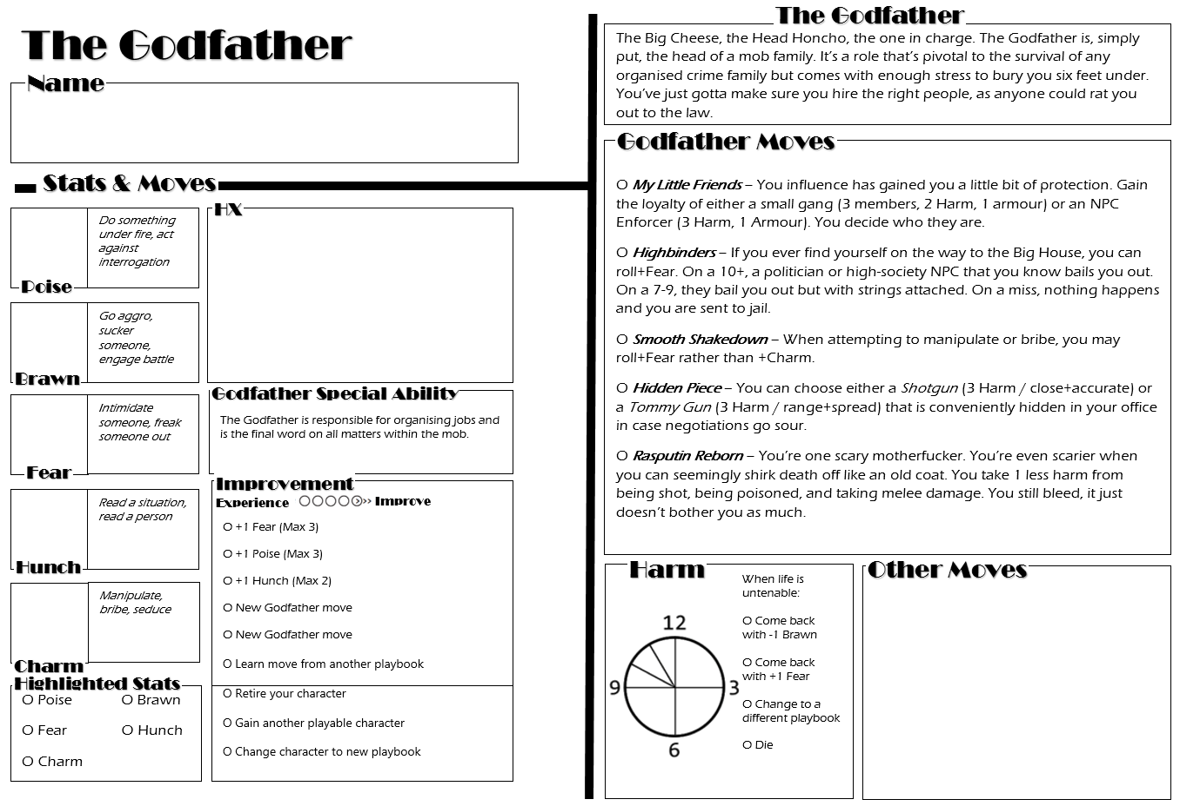
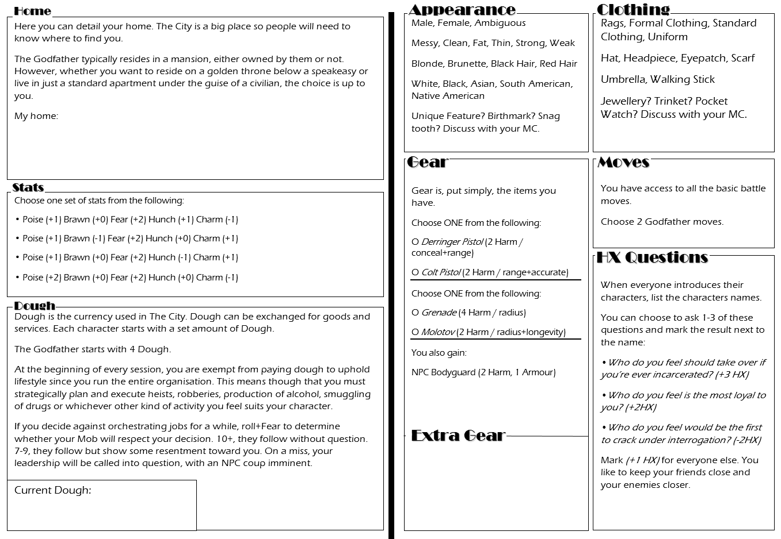
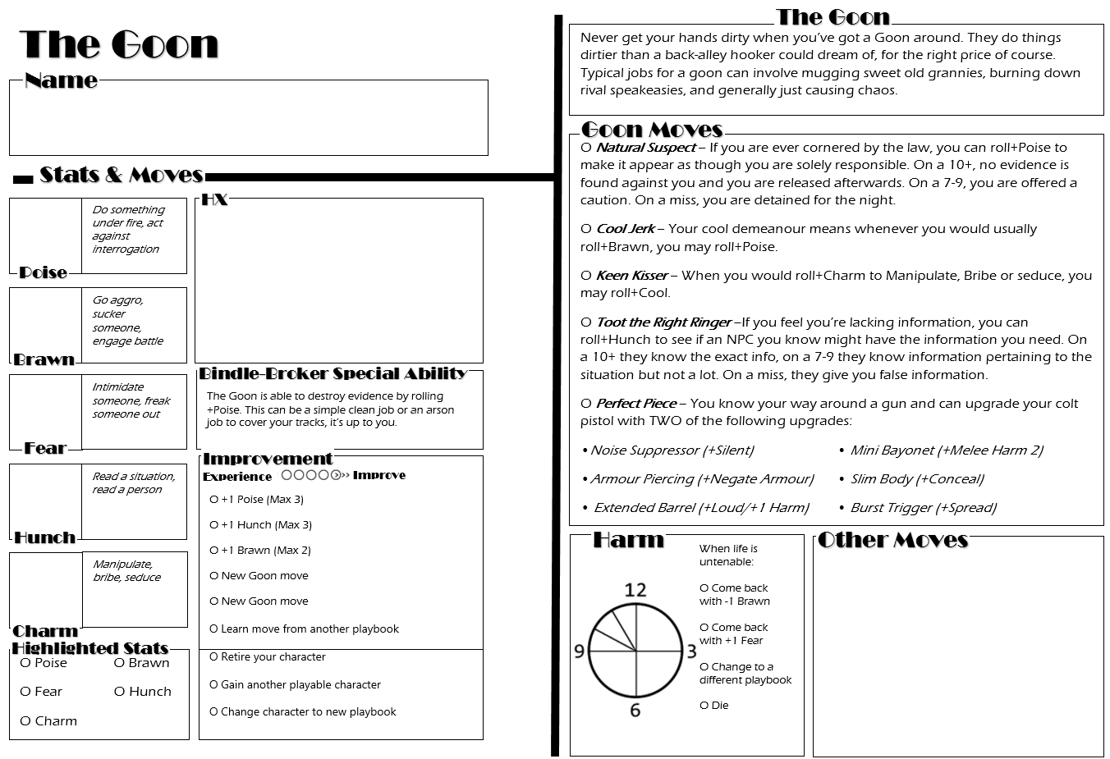
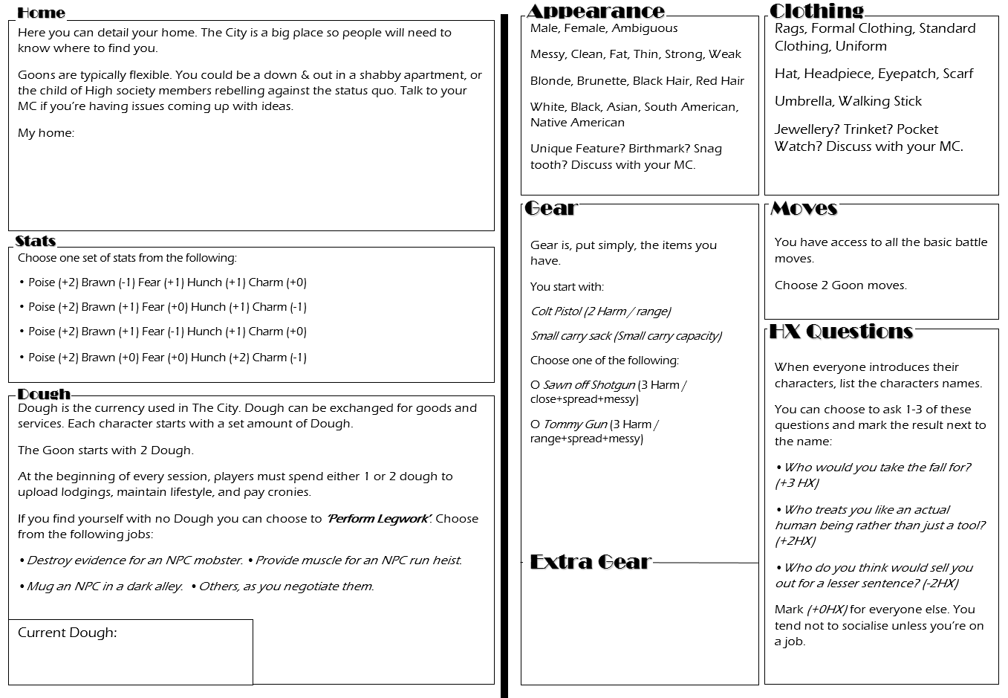
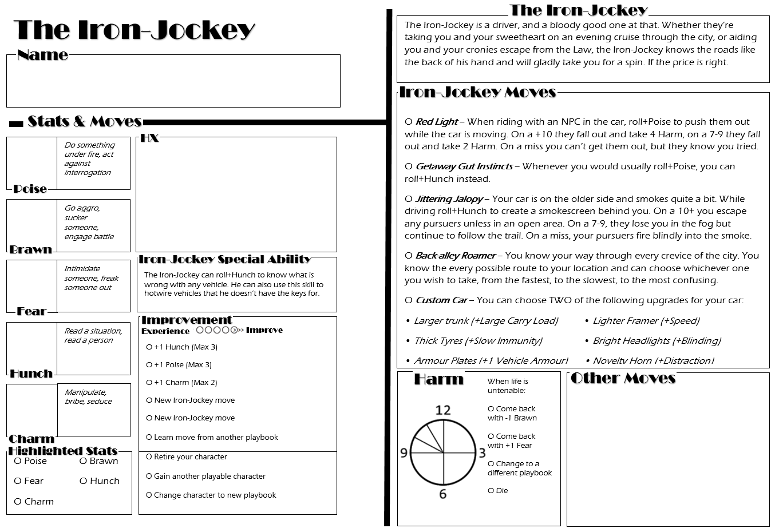
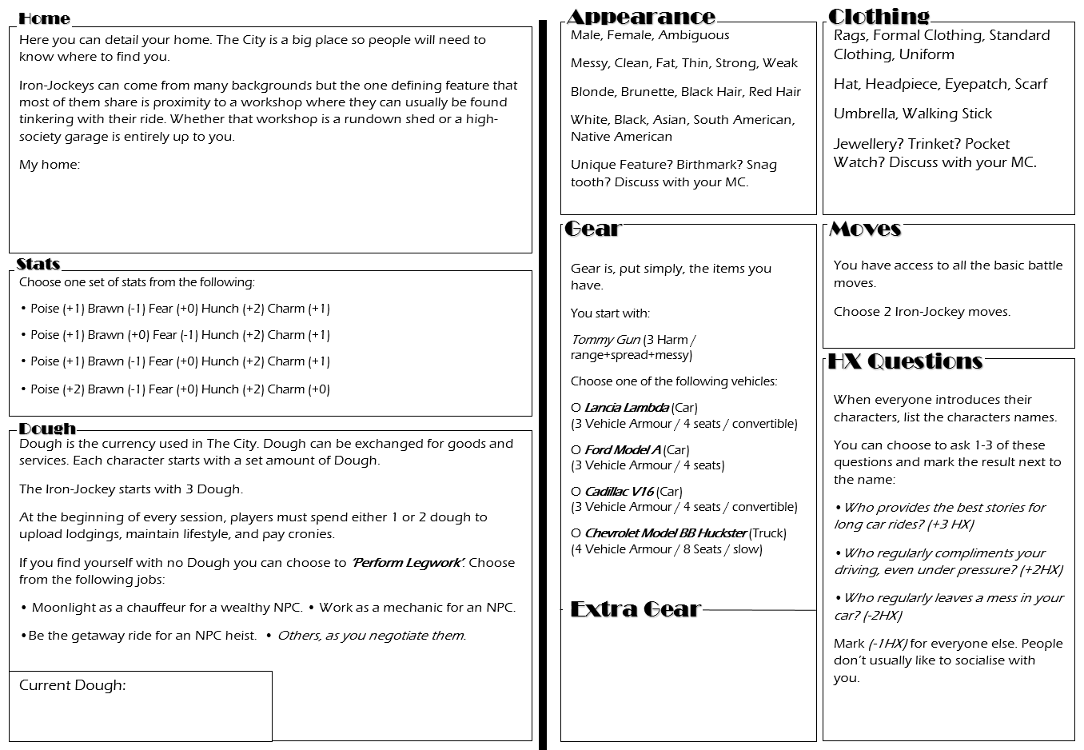
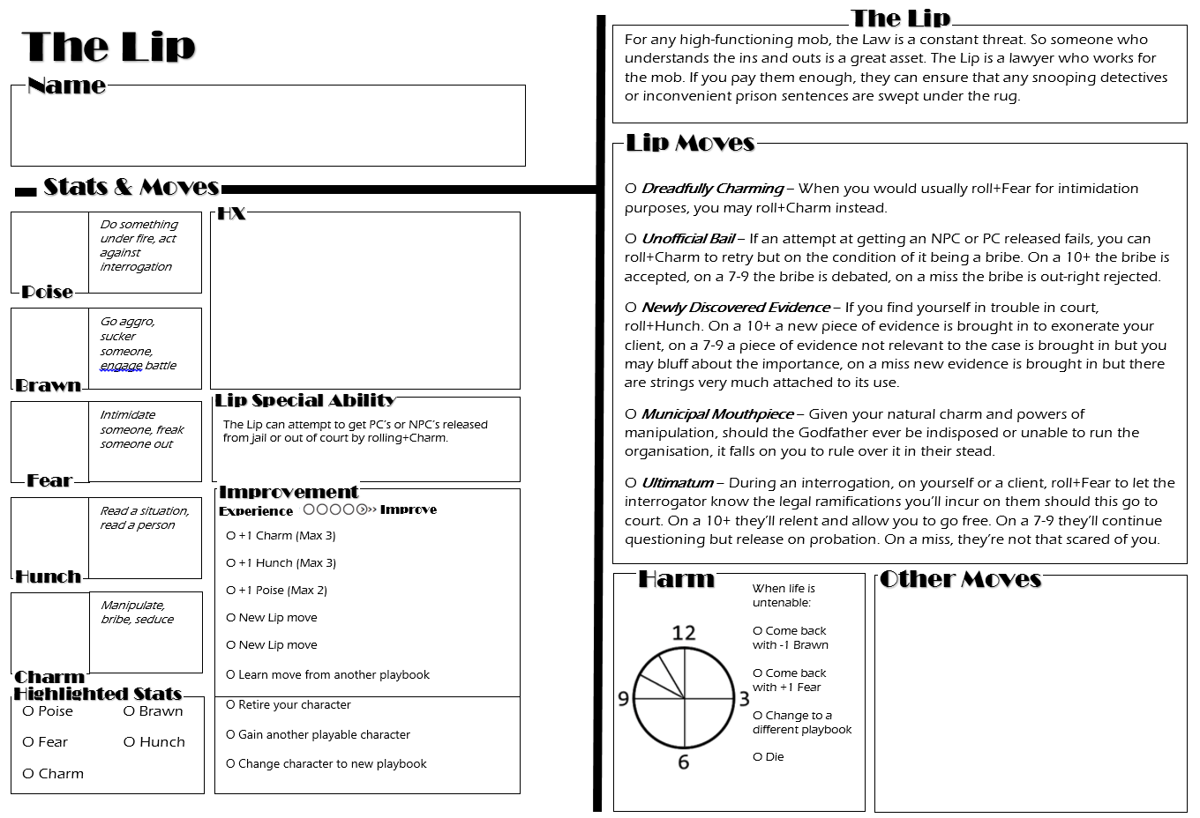
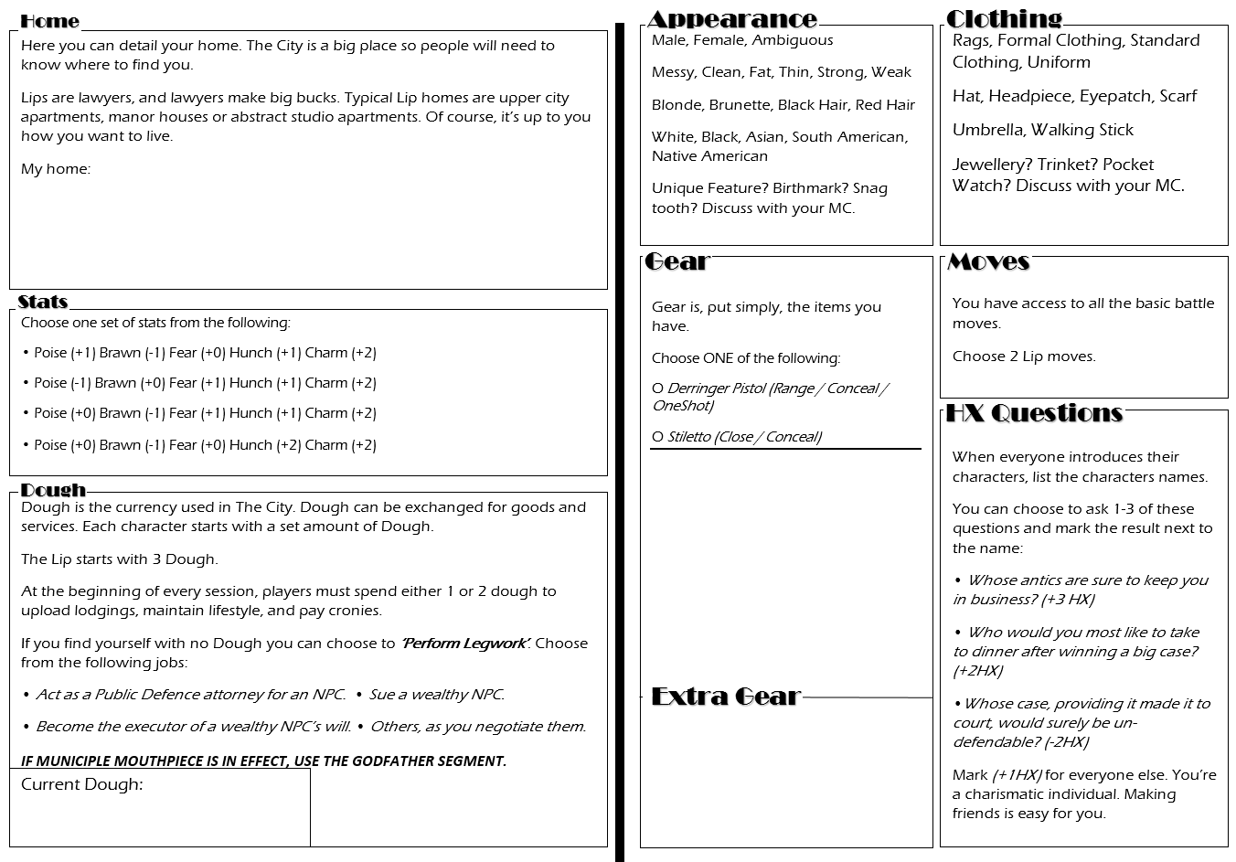
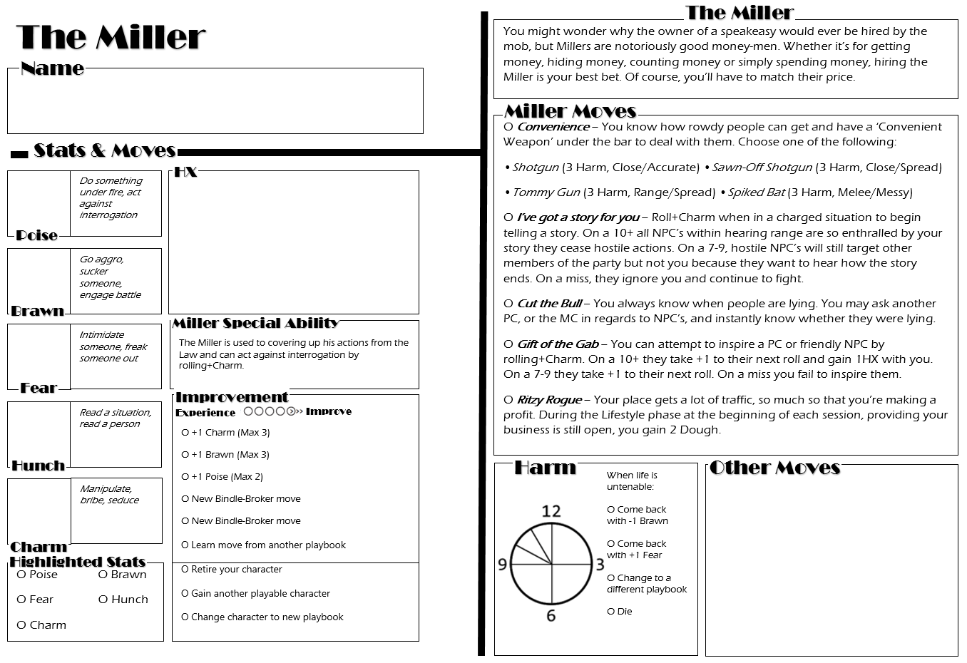
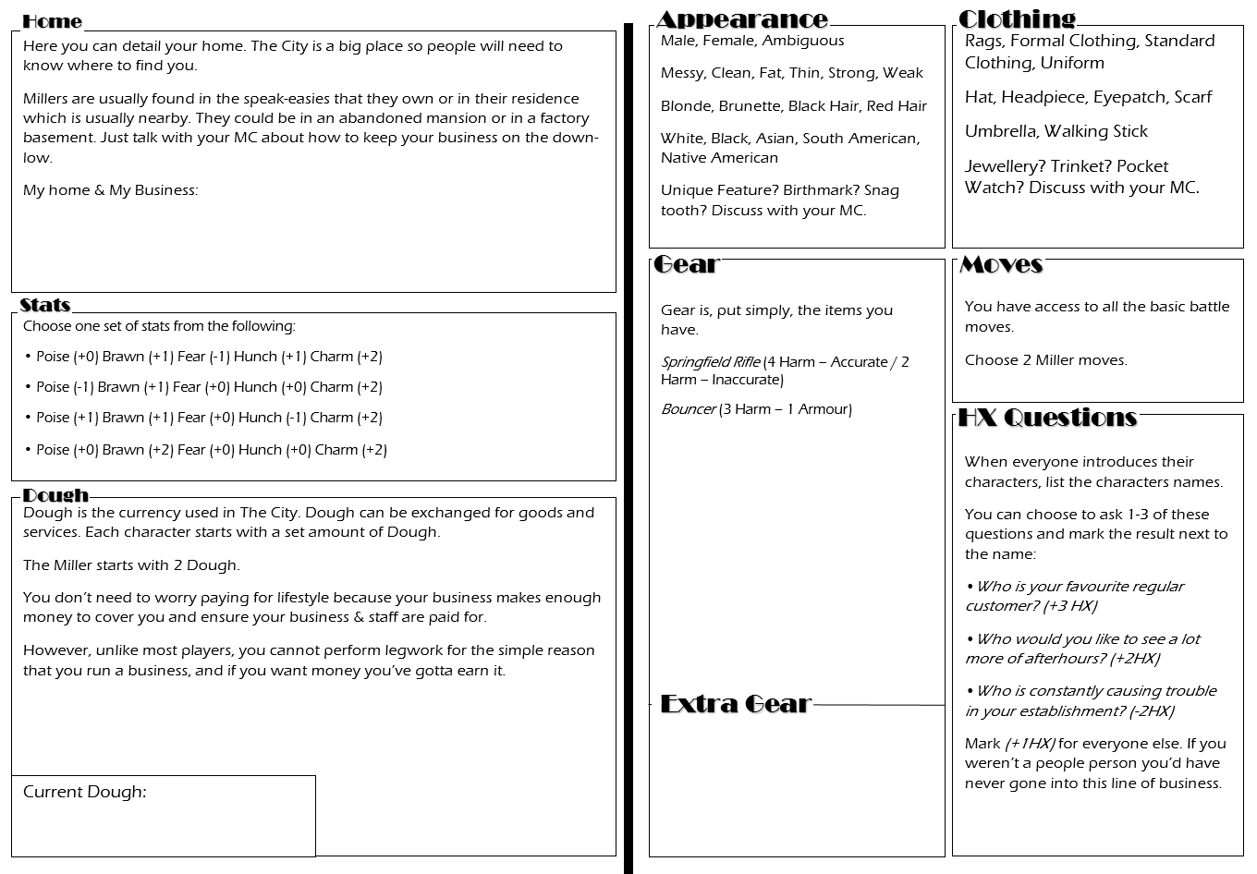
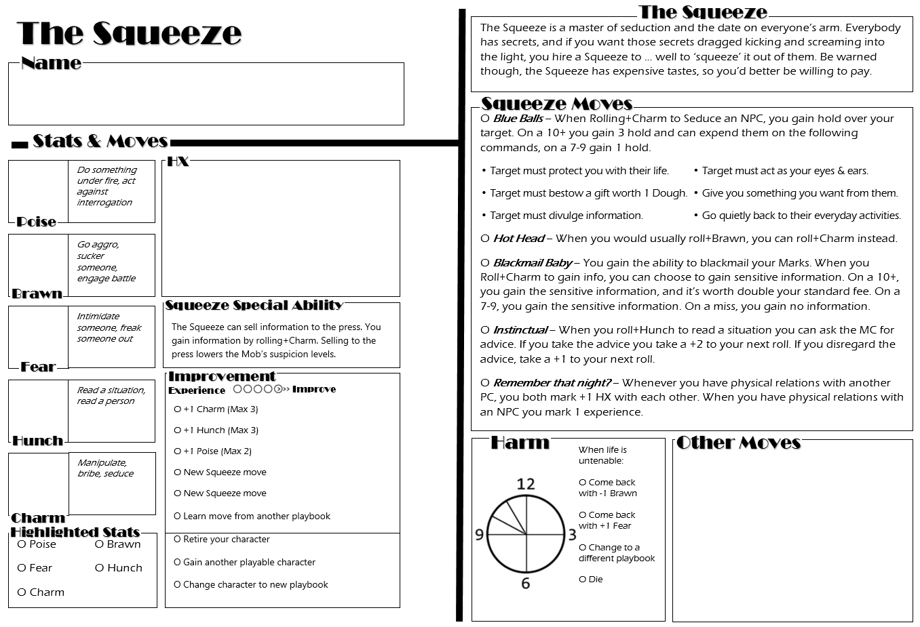
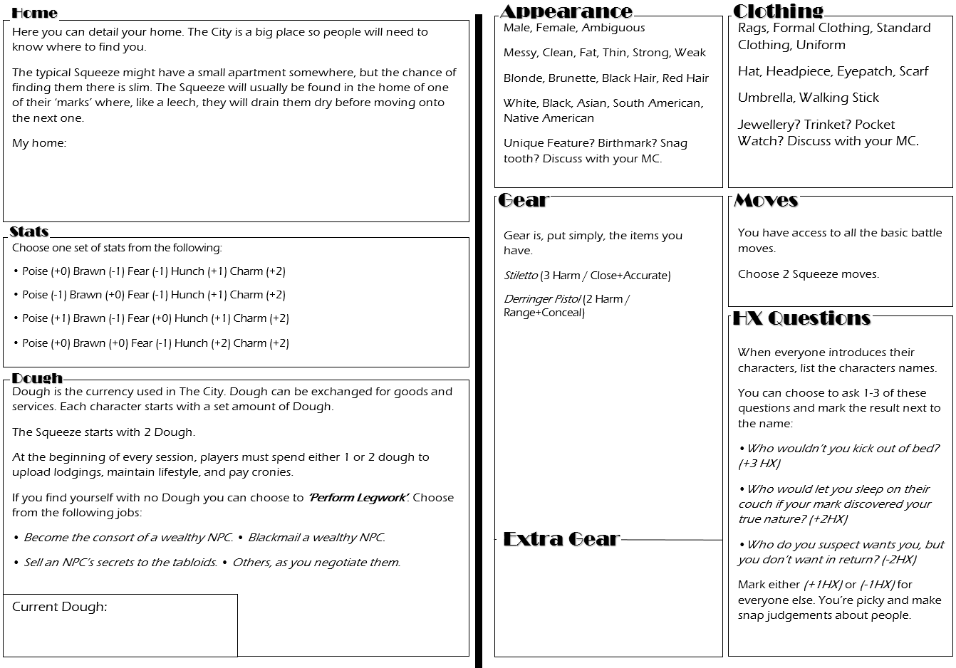
Rolling Under Fire & Against Interrogation
When rolling under fire, roll+Poise. This can be for anything from digging into cover during a firefight, to back-flipping out of a window. On a 10+ you will succeed in your course of action. On a 7-9 you may flinch or hesitate allowing the MC to offer you a compromise or hard bargain. On a miss, prepare for the worst.
When rolling against interrogation, roll+Poise. On a 10+, you tell them what they want to hear, regardless of whether it’s true or not. On a 7-9, they’re suspicious of what you tell them so you’ll need to be convincing or offer up some small truths. On a miss, be prepared for the worst.
Going Aggro
When going aggro, roll+Brawn. Aggro changes your behaviour and determines how your enemies or allies will respond to you, and whether or not they’d wish to engage you in combat. If you roll a 10+ choose THREE of the following behaviours. On a 7-9 choose ONE.
• Tensed muscles and intimidating stance. • Practice swinging of a melee weapon.
• Bloodlust in eyes and menacing glare. • Readying of a gun aimed at them.
• Clenched fists and cracking joints. • Maniacal smile and eerie laugh.
On a miss, choose ONE behaviour anyway but be prepared for the worst.
Sucker Someone
When you attack someone who is unsuspecting or helpless, ask the MC if you could potentially miss with your attack. If you could, treat it as going aggro, but your victim has no choice but to cave in to your demands. If you couldn’t miss, you simply inflict the harm as established.
Intimidation & Scare Tactics
When you want to intimidate or scare someone, roll+Fear. Tell your MC exactly what you want from this person and what you’ll do if they don’t give it to you. On a 10+ they must choose one of the following options.
• They force your hand and have to deal with the consequences.
• They cave and will do what you want them to do.
On a 7-9, they must choose one of the above options and one of the below options.
• They make for the nearest exit as quickly as possible afterwards.
• They barricade themselves securely away from you.
• They give you what they think you want, or tell you what you want to hear.
• They back away calmly, hands where you can see them.
On a miss, prepare for the worst.

Reading a Person
When you want to read a person, roll+Hunch. On a 10+, ask the PC or MC you’re interacting with THREE of the following. On a 7-9, ask ONE.
• Is this character telling the truth? • What does this character feel about this?
• What does this character intend to do? • What does this character wish I’d do?
• How could I get your character to _? • How much does this character know?
On a miss, ask ONE question but be prepared for the worst.
Reading a Situation
When you want to read a situation, roll+Hunch to ask the MC questions. On a 10+, THREE of the following questions. On a 7-9, ask ONE.
• Where’s my best escape route/way in/way past? • Who’s in control here?
• Which enemy is the most vulnerable to me? • What’s my enemy’s true position?
• Which enemy is the biggest threat? • What should I be on the lookout for?
Whenever you act on the MC’s answers, gain a +1 to the roll. On a miss, ask ONE question but be prepared for the worst.
Seduce & Manipulate
When you want to try and Seduce, Manipulate, Bluff, Fast-talk or Lie to someone, tell them what you want them to do, give them a reason, and roll+Charm.
For NPCs: On a 10+, they’ll go along with what you say, unless some fact or action betrays what you told them. On a 7-9 they’ll go along with you but they’ll need some reassurance or evidence first.
For PCs: On a 10+, both of the following, on a 7-9, choose ONE.
• If they go along with you, they mark experience.
• If they refuse, you get to erase one of their highlighted stats for the remainder of the session.
What they do then is up to them.
On a miss for either NPC or PC, be prepared for the worst.

Basic Moves
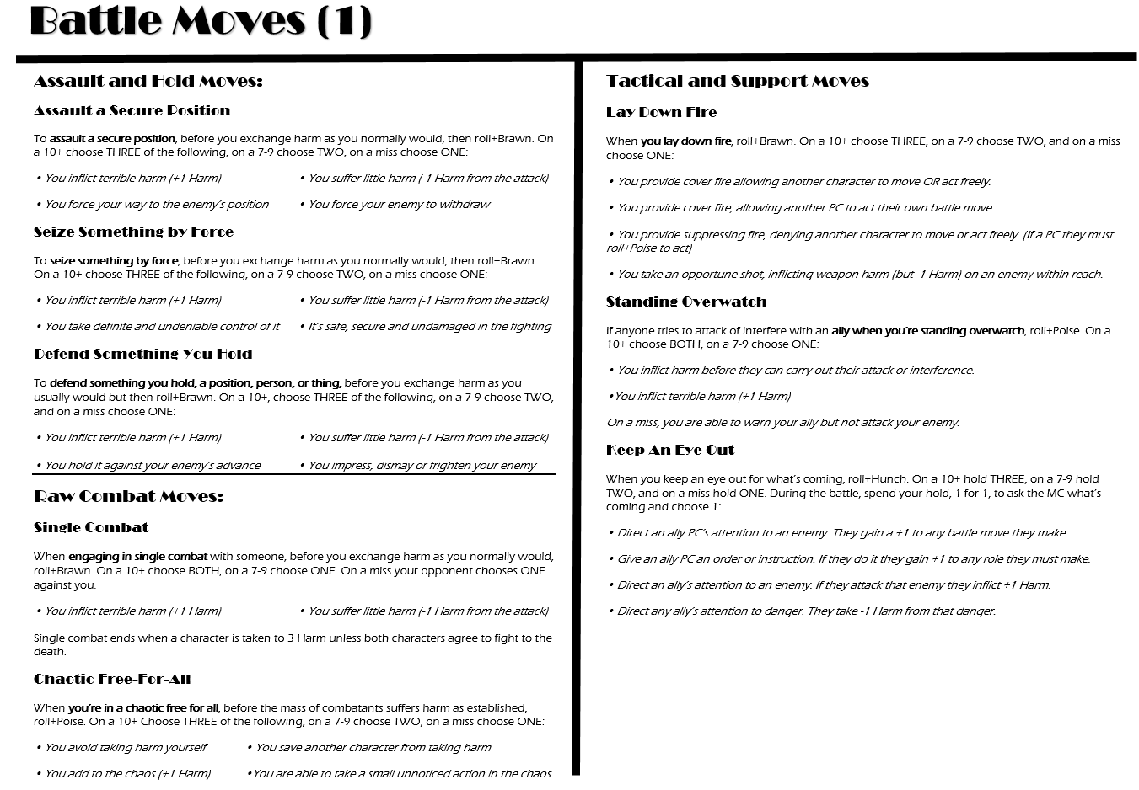
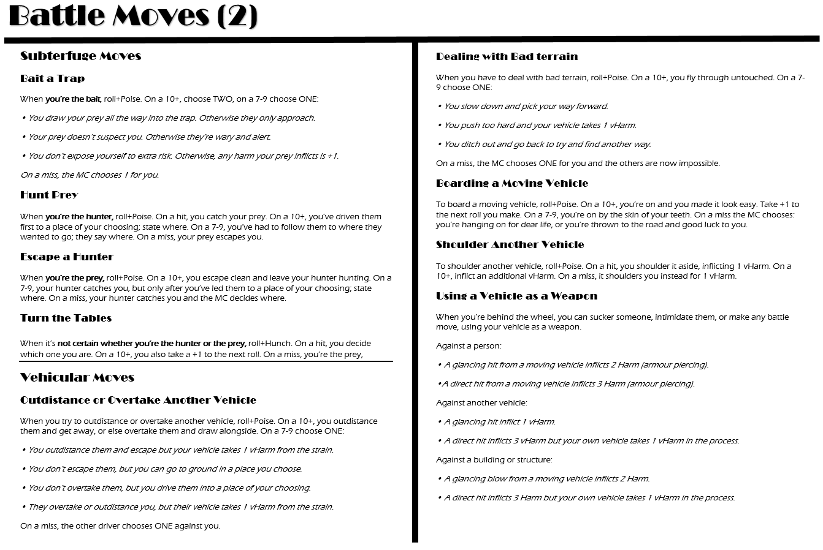
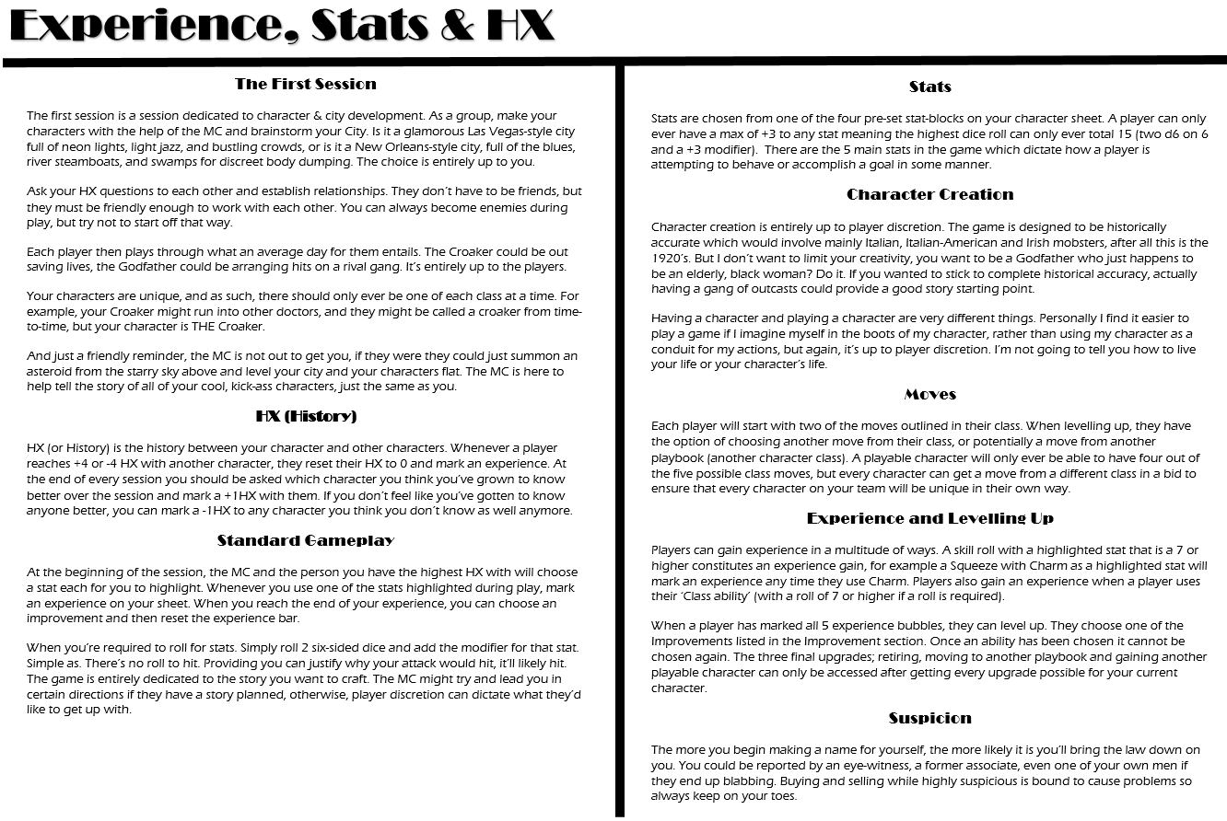
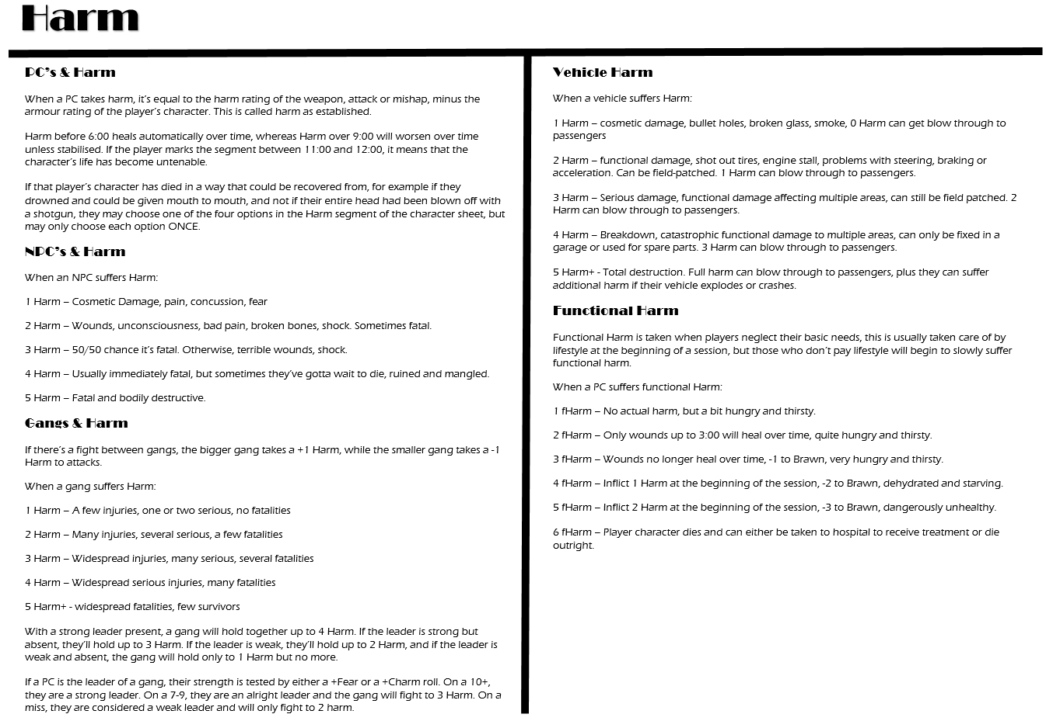
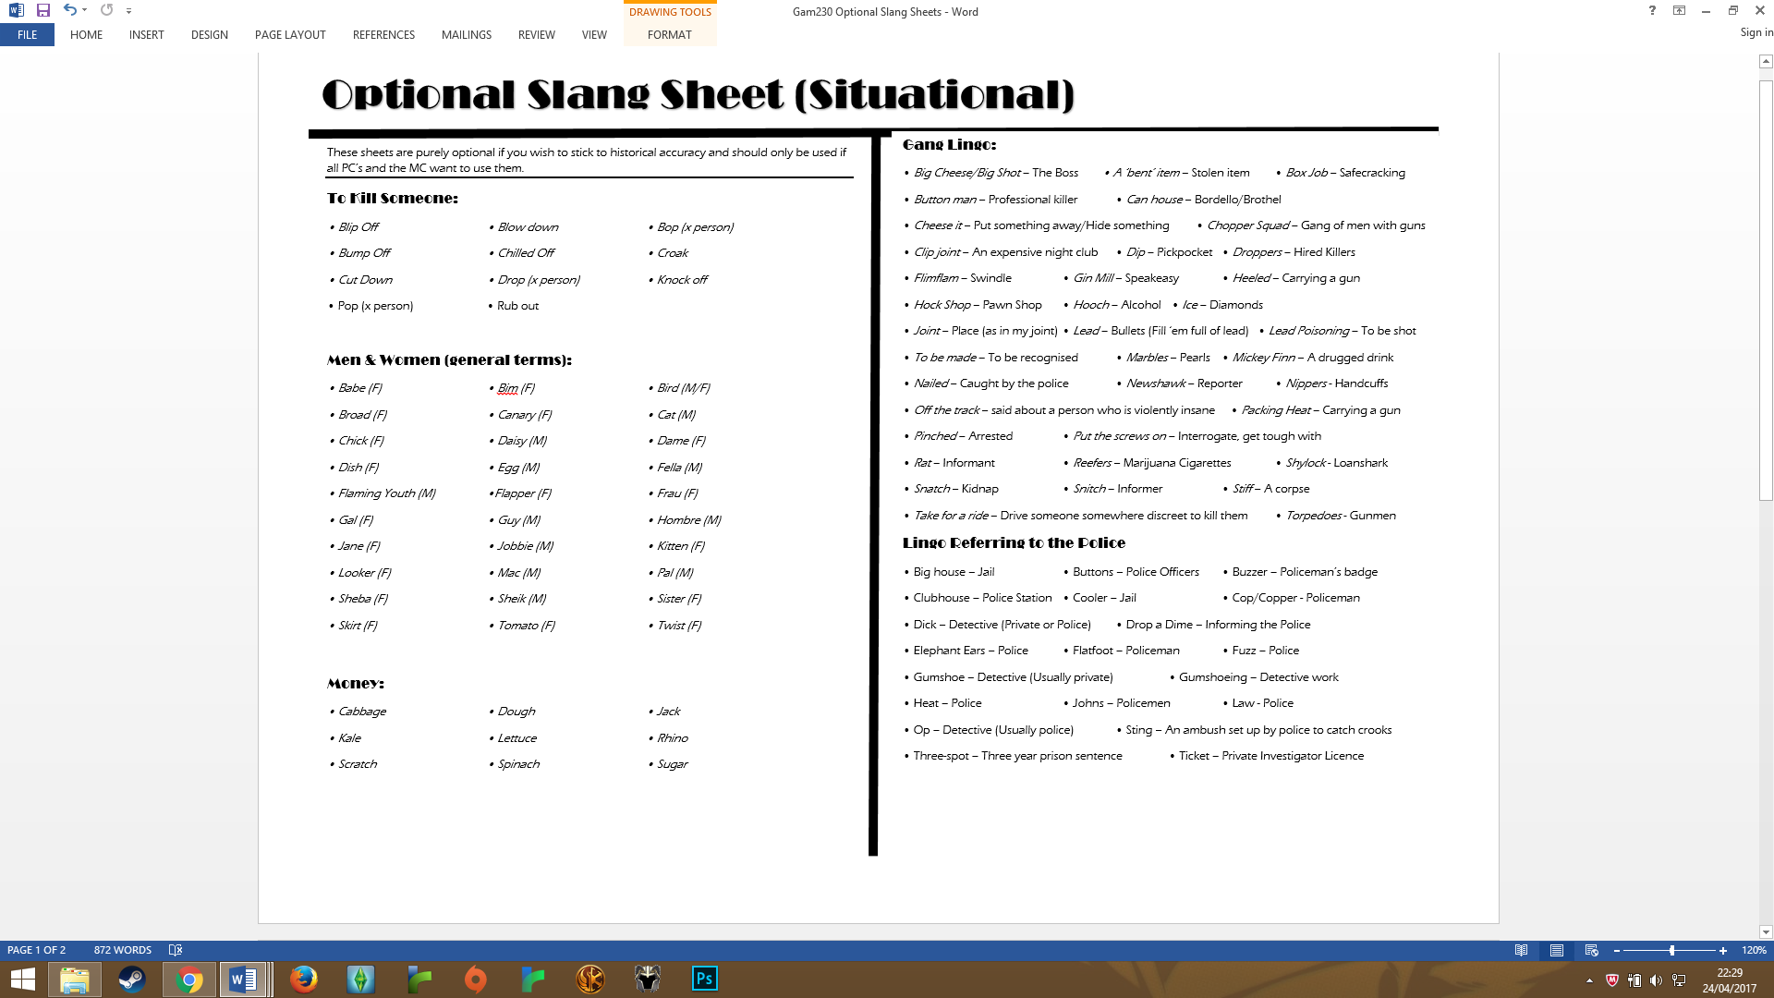

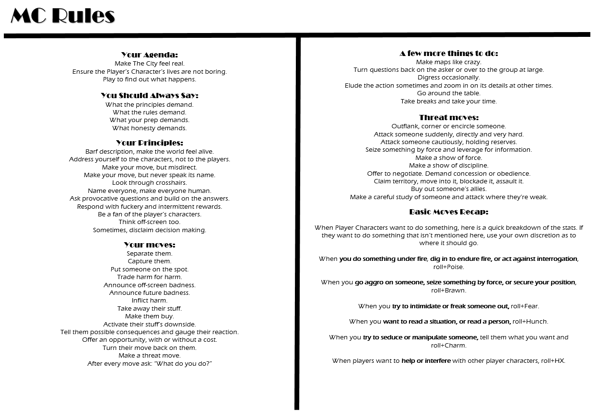
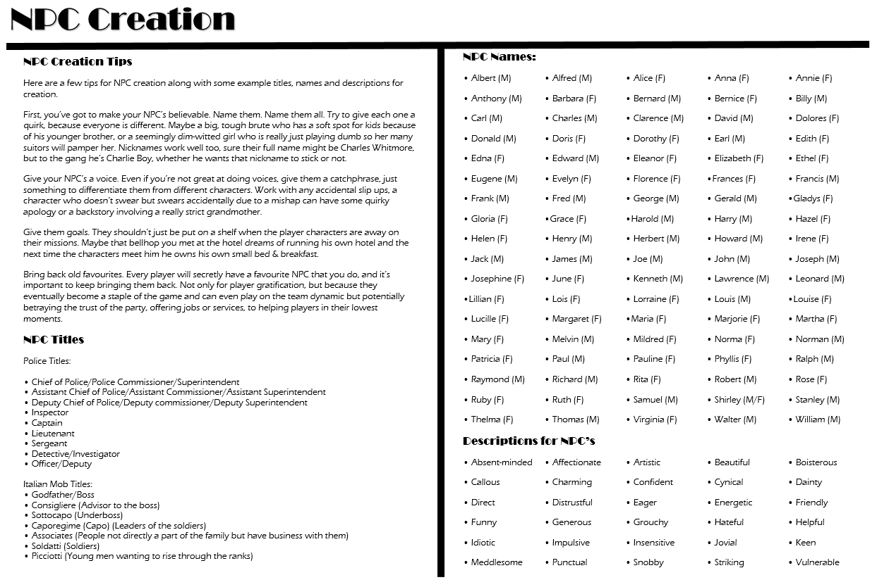

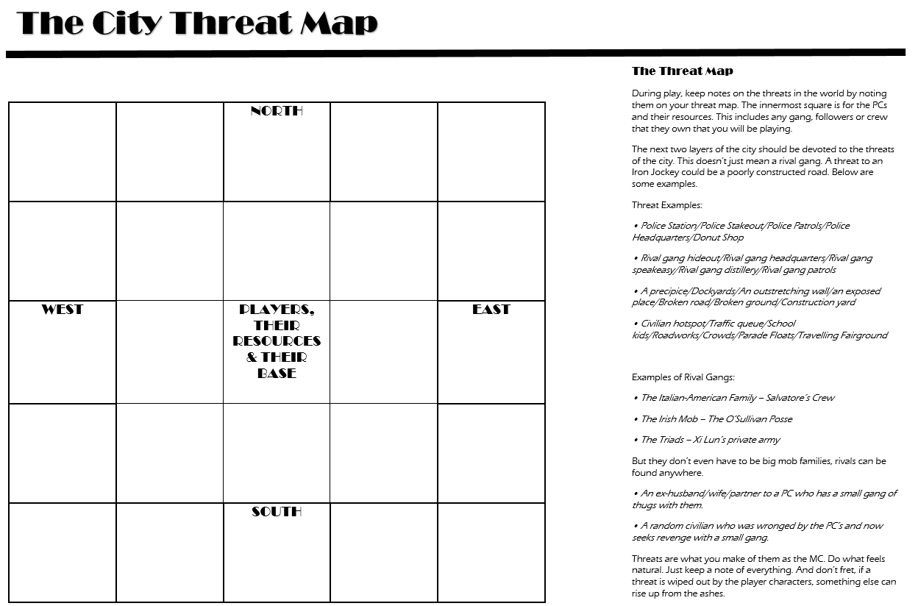
Credits:

Written and Designed by Niall MacDonald

Artwork by Isobel Ackrill

Design Feedback by Jaie Blunt, Liam Phillips & Ostin Tullener

References:
http://apocalypse-world.com/AW2ndEdPlaybooksPreview.pdf
http://mollsanddolls.blogspot.co.uk/2007/10/1920s-slang-dictionary.html
http://www.rsdb.org/full
http://www.1920-30.com/automobiles/

